**APPENDICES**

1. SOP 2.15 Roles and Responsibilities of START Personnel
2. SOP 2.4: START Participant Recruitment, Consent, Enrolment
3. SOP 2.7: Dried Blood Spot (DBS) Collection and Handling

**SOP 2.15: Roles and Responsibilities of START Personnel**

### **PURPOSE**

This standard operating procedure (SOP) is to describe the key roles and responsibilities for all personnel specifically in relation to model 4: Streamlined ART initiation (START).

### **SCOPE**

This SOP applies to all personnel working at sites where START is an intervention.

**MATERIALS**

START Enrollment Form

START Time & Motion Form

START ART Assessment Form

START POC CD4 Log Book

PIMA machine and materials for POC CD4 testing

**RESPONSIBILITIES**

### All personnel involved in the START model are responsible for adhering to the START protocol understanding and following this SOP, and following guidelines for the ethical conduct of patient care at all times.

* **Nurse** is responsible for:
  + Describing START in detail to potential participants
  + Conducting venous blood draw for routine hematology/chemistry tests
  + Conducting same day CD4 testing and urinalysis and recording CD4 test results
  + Determining preliminary eligibility for ART initiation for purposes of START enrolment
  + Recruitment and enrolment of eligible patients
  + Initiating the Time & Motion form
  + Completion of the START Enrolment form
* **Lay Health Care Worker** is responsible for:
  + Identifying pre-ART patients who are due for CD4 count and potentially eligible for START participation
  + Facilitating smooth flow for the patient throughout the clinical visit
  + Completing the Time & Motion form
  + Transferring patient ARV files between the clinician, adherence counselor, pharmacist, nurse, and data associate for final entry care into SmartCare
* **Clinician** is responsible for
* Determining final eligibility for ART initiation
* Prescribing ARVs and other medicines as appropriate
* Providing pre-ART counseling
* Providing the next clinical appointment date
* **Adherence Counselor** is responsible for
  + Providing pre-ART counseling
  + Completing the ART assessment form
* **Pharmacy Technologist** is responsible for
  + Dispensing ARVs and other medicines
  + Entering data into the SmartCare pharmacy form
  + Providing the next pharmacy appointment date
* **Data Associate** is responsible for entering participant data into SmartCare
* **The QA/QC Coordinator i**s responsible for overseeing all quality control procedures related to this model

**PROCEDURES**

1. Patients will be identified by **the lay HCW** for enrollment into the START model from two points in the facility.
   1. First, from the enrollment room at the facility, where a patient with a referral slip (yellow slip) will be sent for their initial visit after learning of their HIV+ status.
   2. Second, from the registry where patients have already been enrolled as clients at the facility, however, due to their CD4 count have not yet been eligible for initiation of ART.
2. After potential candidates have been identified by the Lay HCW, they will be referred to the **Nurse** who will
   1. Introduce themselves to the participants and clearly explain the START model.
   2. Inquire whether the patient is interested in participating in START.
      1. For patients unwilling to participate in START, thank them for their time and refer them to proceed through the clinic as per regular standards.
      2. If the patient is interested, conduct (a) venous blood draw for renal, liver, and hematology tests according to national guidelines (routine Creatinine, ALT, AST and Hemoglobin) (b) Point-of-care (POC) CD4 test (c) POC urinalysis. The tests should be conducted in that order.
      3. Use the CD4 POC Log Book to document the time that testing for POC CD4 began.
      4. Ask the patient to wait at the facility for the results of the CD4 and urinalysis test.
      5. Enter the CD4 results in the Point of Care Log Book and place the paper result (from the PIMA machine) in the patient’s ART file. The time that the CD4 result was obtained should also be recorded.
      6. The urinalysis result should be documented according to current clinical standards
   3. Determine patient’s preliminary eligibility for ART initiation using National HIV Guidelines and communicate POC CD4 result to the patient.
   4. RN will complete Page 1 of the paper Enrollment form.
   5. Send patient with lay HCW for Clinician visit
3. The **Lay HCW** will
   1. Escort the patient to the Clinician and wait outside the office.
   2. Note the time that the interview with Clinician begins on the START Time & Motion form
4. The **Clinician** will
   1. Complete patient routine history and physical examination
   2. Review the CD4 results and urinalysis
   3. Determine patient WHO staging
   4. Determine patient’s final eligibility for ART initiation using Zambian National HIV Guidelines
   5. Manage any co-morbid conditions as needed
   6. Provide adherence counseling and treatment preparation
   7. Prescribe medicines and schedule the patient’s clinical next visit.
   8. Address any questions or concerns the patient may have.
5. The **lay HCW** will
   1. Note the time that the interview with Clinician ends on the START Time & Motion form
   2. Escort the patient to the adherence counselor and wait outside the office.
6. The **Adherence Counselor** will
   1. Conduct adherence counseling with the patient
   2. Complete the ART Assessment Form
   3. Answer any questions patient may have regarding their care and treatment.
7. The **lay HCW** will
   1. Escort the patient to the pharmacy to collect their drugs.
   2. The lay HCW will record the time the patient receives medications from the pharmacist using the Time & Motion form
8. The **Pharmacy Technologist** will
   1. Provide additional adherence counseling to the patient
   2. Answer any questions the patient may have.
   3. Provide the patient with any medications prescribed by the Clinician
   4. Document drug dispensation in SmartCare pharmacy form
9. The **lay HCW** will
   1. Collect the patient’s ARV file from the pharmacist and provide it to the nurse.
10. At the end of the day, the **nurse** will:
    1. Complete the Enrolment Form, page 4 (START only) using the patient’s ARV file
11. The **lay HCW** will take patient ARV files to the data associate for entry into SmartCare

### **ABBREVIATIONS AND ACRONYMS**

SOP *Standard Operating Procedure*

START *Streamlined ART Initiation*

HCW *Health Care Worker*

*RN Research Nurse*

*DBS Dried Blood Spot*

**3.0 START MODEL FLOWCHART**

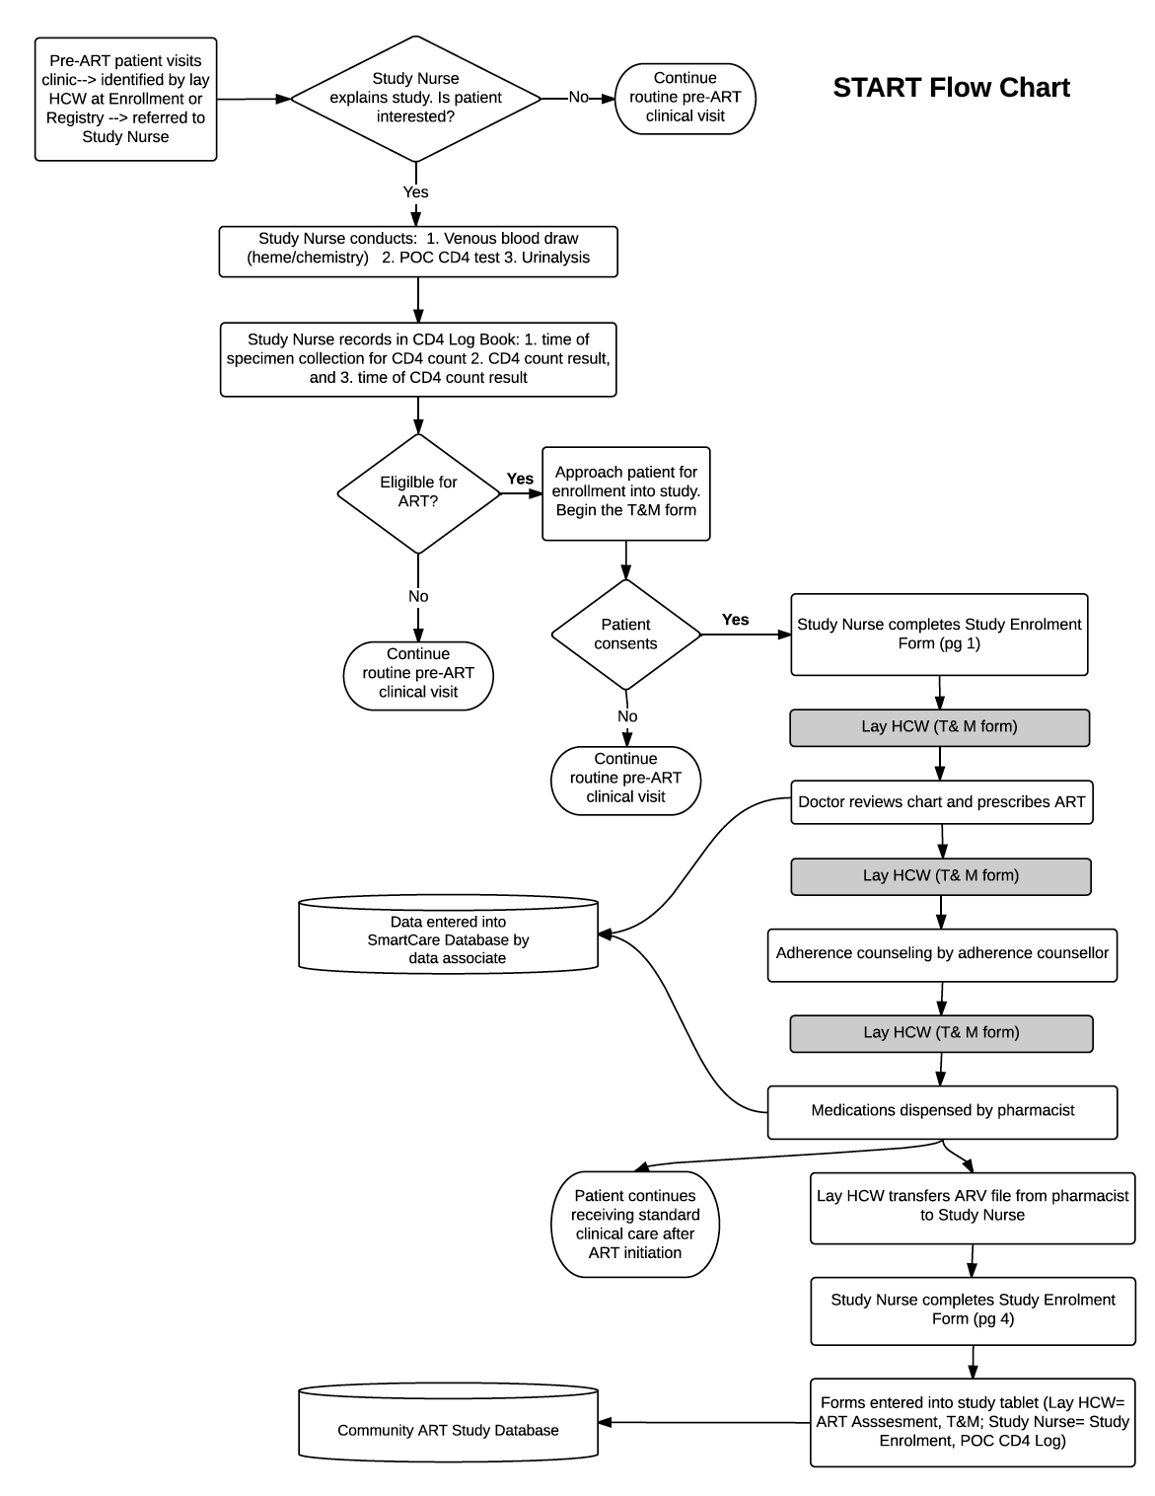

**SOP 2.4: START Participant Recruitment and Enrolment**

### **PURPOSE**

This standard operating procedure (SOP) describes the procedures to be followed when recruiting and enrolling patients for Streamlined ART initiation (START) model

### **SCOPE**

This SOP applies to all personnel involved in recruitment and enrolment of study participants.

**MATERIALS**

START Comprehension Assessment Tool

Enrollment Form

Point of Care CD4 Log Book

START Time & Motion Form

**RESPONSIBILITIES**

### All personnel involved in recruiting and enrolling patients for START model in the Community ART study are responsible for adhering to the SMART protocol, implementing appropriate procedures, understanding and following this SOP, and following guidelines for the ethical conduct of patient care at all times.

### **Lay Health Care Worker** is responsible for approaching potential participants for recruitment in the study

* **Nurse** is responsible for enrolling participants in compliance with the requirements of this SOP
* **QA/QC Coordinator i**s responsible for overseeing all quality control procedures

**PROCEDURES FOR RECRUITMENT**

* Patient will be identified by the **lay HCW** for recruitment into the START study model from two points in the facility.
  + **First,** from the enrollment room at the facility where a patient with a referral slip will be sent for their initial visit after learning of their HIV+ status.
  + **Second,** from the registry where patients have already been enrolled as clients at the facility, however, due to their CD4 count have not yet been

eligible for initiation of ART.

* The **Lay HCW** will:
  + Introduce themselves to the potential enrollee
  + Briefly explain the START model to the patient
  + Ask if patient is interested
  + If interested, escort the patient to the Nurse
  + If not interested thank the patient for their time.

* A**ssessing for ART Eligibility**

The **Nurse** will,

* + Introduce themselves and thank the patient for their time
  + Clearly explain the START model.
    - Conduct (a) venous blood draw for renal, liver, and hematology tests according to national guidelines (routine Creatinine, ALT, AST and Hemoglobin) (a) point-of-care (POC) CD4 testing (b) POC urinalysis. The tests should be conducted in that order.
    - Use the CD4 POC Log Book to document the time that testing for POC CD4 is begun.
    - Ask patient to wait at the facility for the CD4 and urinalysis results to be ready.
    - Enter the CD4 results in the Community ART Point of Care Log Book and place the paper result (from the PIMA machine) in the patient’s ART file. The time that the CD4 result was obtained should also be recorded.
    - The urinalysis result should be documented according to current clinical standards
    - Nurse will then assess for preliminary eligibility for ART initiation.

*Criteria for ART eligibility (Zambian National HIV Guidelines):*

* + - * All confirmed HIV-infected children and adolescents <15 years old regardless of CD4 count and/or World Health Organization Clinical Stage (WCS)
      * Adolescents ≥15 years old and adults with CD4 count ≤500 cells/mm3 regardless of WCS
      * Starting lifelong triple combination ART (cART) regardless of CD4 count and WCS:
        + Pregnant & breastfeeding women
        + HIV-infected sexual partners of pregnant & breastfeeding women
        + HIV-infected partners in serodiscordant couples
        + Patients with active tuberculosis (TB) disease
        + Patients with hepatitis B virus (HBV) co-infection with severe liver disease

If the patient does not meet criteria for ART initiation, they will be informed to continue with standard of care at the clinic (including returning to clinic in 6 months for repeat testing).

**PROCEDURES FOR ENROLLMENT**

* If eligible, the nurse will:
* Complete the Enrolment Form, page 1
* Refer the patient to the Clinician
* The lay HCW will escort the patient through the clinical visit as outlined in SOP *2.15 START Roles and Responsibilities.* When the patient is done with their clinical visit, the lay HCW will (a) enter the ART Assessment Form & the Time & Motion form into the database and (b) will retain the patient’s ARV file and provide the file to the nurse.
* At the end of the day, the nurse should:
* Complete the Enrolment Form, page 4 (START only) using the patient’s ARV file
* The lay HCW will then give the patient ARV files to the data associate for entry into SmartCare

### **ABBREVIATIONS AND ACRONYMS**

SOP *Standard Operating Procedure*

START *Streamlined ART Initiation*

HCW *Health Care Worker*

**SOP 2.7: Dried Blood Spot (DBS) Collection and Handling**

**PURPOSE**

This SOP outlines the procedure to be followed when Dried Blood Spot (DBS) samples from a finger prick DBS are collected for viral load testing for HIV RNA. It also outlines the procedures to follow in case of a needle stick injury.

**PRINCIPLE**

A finger prick is done when collecting blood for Dried Blood Spots (DBS). DBS requires a lesser volume of blood with reduced infectious risk making it safer to handle than whole blood. It can also be stored and transported at room temperature (15-30 degrees).

**RESPONSIBILITIES**

All field staff are responsible for understanding and following this SOP.

**STAFF TRAINING REQUIREMENTS**

All staff that collect DBS specimens must have completed formal training before collecting DBS cards and have successfully completed a competence sheet.

**MATERIALS AND EQUIPMENT**

1. Lasec DBS Card
2. Gas impermeable storage bags
3. Desiccant packs
4. Humidity indicator (cards)
5. Alcohol swabs
6. Bandage/Plaster
7. Lancet
8. Drying racks
9. DBS lab requisition form
10. Gloves (always wash off the powder to avoid contaminating the specimens)
11. DBS transport and storage box

**PROCEDURES**

**1. Labeling the DBS card**

The DBS is collected on a Lasec DBS card. Prior to the specimen collection, the DBS cards and lab requisition forms are labeled with the patient’s information.

For this study, we will use the patient ART number. Label the DBS card with the following:

1. Patient ART ID number
2. Site identification number
3. DBS preparation date/time

**2. Collecting specimen for DBS**

1. First, wash your hands before putting on gloves. If you wear powdered gloves, wash and dry your gloved hands to remove as much powder as possible.
2. Handle the DBS card carefully using the edges; NEVER touch the areas where the blood will be collected.
3. Use whole blood sample from finger prick.
4. Make sure to warm the participant’s hand and make sure the hand is below the level of the elbow (to allow gravity to help you collect the blood).

**NOTE:** When you do the finger prick sometimes blood comes out very slowly especially if it is cold or the person has thick skin. A lot of the time the instinct is to squeeze the finger WHICH IS WRONG, but a better way to do it is to make sure that the finger is pointing down (below the palm) and to squeeze the palm broadly instead.

1. Select finger for the procedure. Clean patient finger with disinfectant or alcohol wipe, generally middle or ring finger is preferred, avoid fingers with rings on.
2. Allow to air dry for 30 seconds.
3. Use a sterile, disposable lancet to puncture the skin to the side of the fingertip.
4. Dispose of the lancet in the biohazard container.
5. With the finger extended, wipe away the first drop of blood then allow a large, hanging drop of free-flowing blood to accumulate at the puncture site.
6. To collect the drop of blood, touch the filter paper to the edge of the drop, allowing the blood to be drawn into the first circle on the card by capillary action. DO NOT allow the finger to touch the card.
7. Then, allow another large drop of free-flowing blood to form at the puncture site and collect this drop in the **NEXT** circle.
8. You need only **ONE LARGE DROP PER CIRCLE.** Do not layer multiple drops of blood on top of each other.
9. Continue collecting drops of blood in the same manner until all the circles are filled on the DBS card (Fig 1. and 2.).

**Fig 1. Valid DBS cards**

All DBS must be collected on Lasec paper

Identifying information on the DBS card must match information on the lab requisition form

At least 3 spots 6mm in diameter or larger must be obtained

After drying, DBS should be dark and uniformly coloured



NAME*: JP 5040-133-0000-1*

DATE: *14/11/2014*

DOB: *01/10/2014*

Facility: *Kalingalinga - ALERE*

District: *Lusaka*

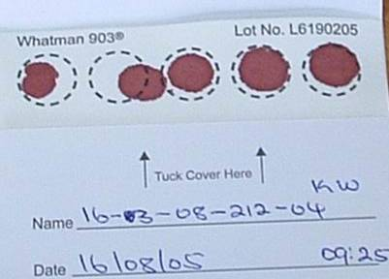

All 5 circles filled. At least 3 are valid.

**Fig2. Invalid DBS card**

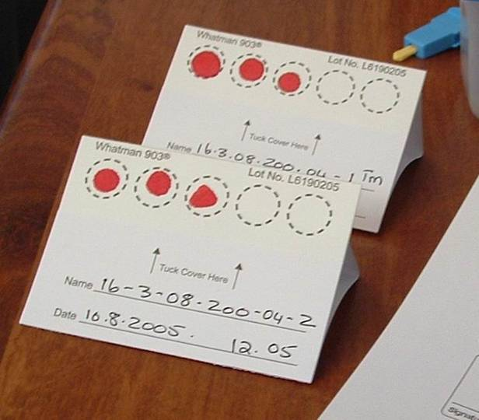

Blood spots are too small

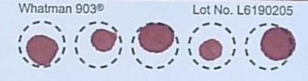

**4** Circles not filled

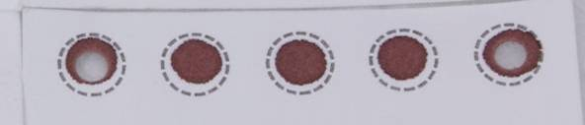

4.2**.** Blood has clotted

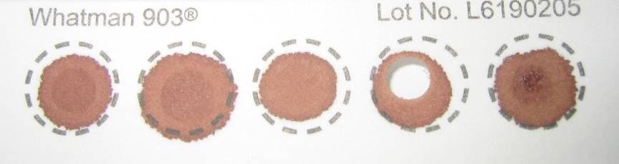

Specimen has clotted and appears layered

1. If the blood stops flowing before sufficient blood has been collected, gently massage the hand to encourage blood droplets formation. **DO NOT MILK THE FINGER** (i.e. do not squeeze or massage the finger area).

If necessary, a second finger can be cleaned and punctured using a new lancet in order to obtain adequate sample. It is important that adequate sample is collected; you must saturate each circle with blood.

1. If you are unable to obtain flowing blood using finger stick despite multiple attempts, please inform a head nurse or clinician.
2. After adequate sample is collected, give the participant gauze or swab to hold pressure to the fingertip. Elevate the fingertip above the elbow. After a matter of seconds or minutes, the bleeding should stop. No strapping, plaster, or band-aid is needed.

**3a. Handling specimen after collection in the CLINIC**

This section describes the procedure for handling a collected DBS specimen in the clinic.

1. After completing the sample collection, place the DBS card on the drying rack (Fig 3). The drying rack should ideally be placed so that the DBS cards dry in the horizontal position.
2. If no drying rack is available, the DBS card can be laid flat on a clean paper towel.
3. Fill out the lab requisition form and leave it close to the DBS card, so it can accompany the card to the lab, once dry.

**Fig 3. DBS on drying rack**

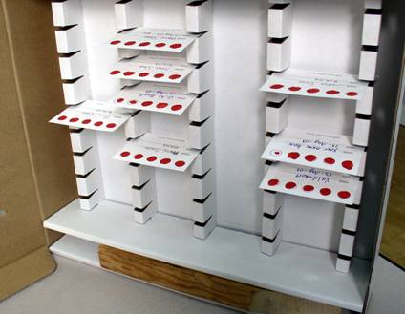

PRECAUTIONS WHEN DRYING THE DBS CARDS:

* Do not touch or smear the blood spots
* Keep away from direct sun-light, dust, and insects
* Do not heat, stack or allow DBS to touch anything during the drying process (including other DBS cards)

1. DBS cards must dry for at least 4 hours (though preferably overnight) prior to being placed in plastic bags and transported to the lab. **DO NOT USE AN EXTERNAL HEAT SOURCE TO DRY DBS.**
2. When dry, the spots will appear a uniform dark brown. The appearance should be similar to that of a dried bloodstain and no areas of red coloration should be seen.

**3b. Handling specimen after collection in the FIELD (outside of clinic) using a transport box**

This section describes the procedure for handling a collected DBS specimen in the field (outside of clinic).

1. Follow the procedure above for collecting DBS (2.1-2.16).

1. Allow the DBS card to dry sufficiently so blood is not flowing when placed in a transport box
2. Appropriately place the DBS card horizontally in a rack already provided in the transport box
3. The transport box must be carried horizontally at all times. **PROTECT YOUR DBS CARD FROM ANY DUST OR DIRECT SUNLIGHT AT ALL TIMES.**

1. When you return to the facility at the end of your tracing activities, ensure that each DBS card has had a lab requisition form filled out
2. When you arrive at the facility, remove the DBS card and leave to air dry effectively for 4 hours or till the next morning. If no drying rack is available at the facility, the DBS card can be laid flat on a clean paper towel.

1. Fill out the lab requisition form and leave it close to the DBS card, so it can accompany the card to the lab, once dry. Ensure the first two copies of the lab requisition accompany the DBS card to the lab. Retain the third copy for facility records.

**4. Packaging of DBS**

Packaging of the DBS is very important. DBS cannot be kept and/or transported at ambient temperature for longer than 14 days. If VL testing cannot be performed within 14 days from the date of collection, DBS should be transported to a central facility where there is a constant electricity supply and a -70°C freeze.

The manner in which the DBS are packaged may determine the quality of the results in the future.

1. Once the DBS card is **COMPLETELY DRY**, place the card in a gas-impermeable zip-locked plastic bag with 1 desiccant pack.
2. Humidity causes damage to the HIV virus particles and should be avoided through use of desiccant and humidity cards.
3. The patient information should be visible through the bag. Make sure the humidity card is placed in the rear of the card facing out so that we can read the card and so that it does not obscure the view of the participant information on the card.
4. We want to keep the DBS card sealed in its bag from now to when we are ready to test it. Gently apply pressure to the partially sealed bag to excel the air before sealing completely.
5. Bring the plastic bag containing the DBS along with the lab requisition form to the appropriate area in the clinic so that it can be transported to the reference laboratory. **DO NOT STAPLE THE REQUISITION FORM TO THE PLASTIC BAG** as this will puncture the bag and allow air to enter.
6. Insert DBS bag into envelope. Place lab requisitions and specimen delivery checklist into envelope. Seal envelope. Label envelope clearly (“START DBS specimens”). Send to testing lab.

_______________________________________________________________________

**PROCEDURES FOR NEEDLE STICK INJURY**

Purpose

The purpose of this section is to define procedures to follow when any Community ART staff member suffers a needle stick injury or blood contamination. This procedure applies to all staff involved in collection of blood specimens from Community ART participants.

Responsibilities

The staff members delegated to collect DBS specimens for the studyare responsible for understanding and following this section of the SOP.

The START staff supervisor is responsible for ensuring that START staff knows what action to take when one has a needle stick injury or is exposed to contaminated body fluids when handling and discarding used lancets, broken specimen containers or hazardous waste. In the event of a needle stick injury, the supervisor is responsible for ensuring that the employee receives all necessary medical attention.

Appendices

Standard Operating Procedure: Management of Occupational Exposures to potentially Infectious Substances

**Procedures**

Study staff are to follow the laid down steps in case of needle stick injury and skin exposure while working with a patient with known HIV infection.

1. Immediately wash the site with soap and running water. Antiseptics such as alcohol or chlorohexidine can be used on small wounds and puncture sites – these agents have some virucidal activity. DO NOT USE BLEACH or other caustic agents to clean the exposure site or squeeze the wound.
2. In case of mucosal exposure, the exposed surface should be flushed with numerous amount of saline or water.
3. In case of exposure to the eye, immediately flush with copious amounts of clean water
4. Contact on site or nearby In-Charge/Supervisor. If the In-Charge/Supervisor is not immediately reachable, attempts should be made to reach a head nurse based at the district.
5. The individual with potential HIV exposure should present her/himself nearby health facility for immediate HIV counseling and testing. These results should be made available to health providers during discussions about post-exposure prophylaxis (see below). Should the HIV result be negative, the staff member should follow-up with a repeat test after 3 months.

The individual with potential HIV exposure will be referred to a member of the medical team, who will provide management for post-exposure prophylaxis (see Appendix).

**15.0 Dried Blood Spot (DBS) Viral Load Log Book**

**Dried Blood Spot (DBS) Viral Load Log Book**

**Clinic Name:** _______________________________________________________

|  |  |  |  |  |
| --- | --- | --- | --- | --- |
| **Date of Specimen Collection**  **(DD/MM/YY)** | **Time of Specimen Collection**  **(HH:MM)** | **ART ID** | **Patient First Name** | **Patient Surname** |
|  |  |  |  |  |
|  |  |  |  |  |
|  |  |  |  |  |
|  |  |  |  |  |
|  |  |  |  |  |
|  |  |  |  |  |
|  |  |  |  |  |
|  |  |  |  |  |
|  |  |  |  |  |
|  |  |  |  |  |
|  |  |  |  |  |
|  |  |  |  |  |
|  |  |  |  |  |
|  |  |  |  |  |
|  |  |  |  |  |
|  |  |  |  |  |